Facial Recognition

PCA tries to find a set of eigenvectors. Eliminate some of the eigenvectors based on value. Then project the remaining values from the higher plane onto a lower plane.

Visualizing PCA Eigenvectors

* The set of eigenvectors can be reformed into a face.
* Train on 4,000 aligned images from the Oxford VGG Face dataset
* Obtain the Eigenvectors corresponding to the 4 largest Eigenvalues
  + Called Eigenfaces
* Reshape from 1D vector to 2D image
* 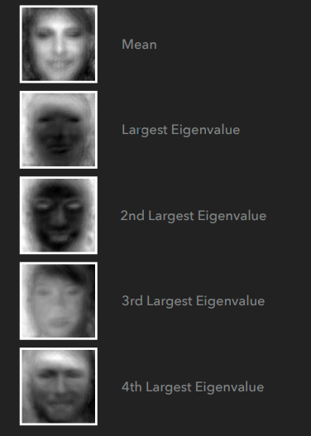
* Linear Discriminant Analysis (LDA)
  + Unlike PCA, LDA makes use of identity information (Supervised Learning)
  + **Goal:** learn a subspace that **minimizes intra-class variation and maximizes inter-class variation** 
    - Images from the same subject are closer together
    - Images from different subjects further apart
  + 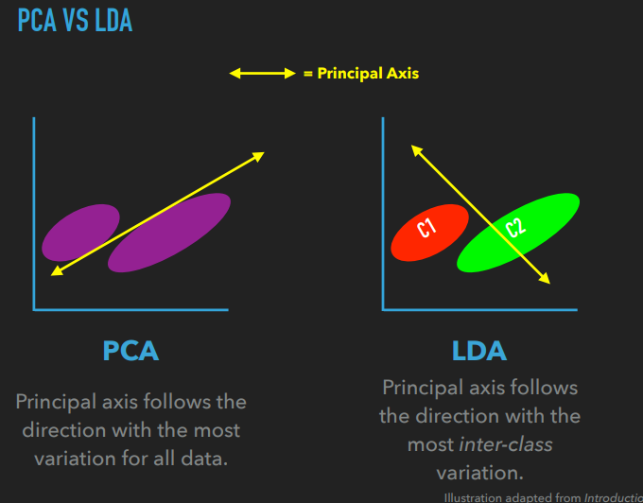
  + PCA is unlabeled data. (same color here)
  + LDA is labeled data.
  + PCA - eigenvectors are computed using the global covariance matrix
  + LDA - eigenvectors are derived from 2 scatter matrices, instead of a single matrix.
    - Within class scatter matrix
    - Between class scatter matrix
* LDA Initialization
  + 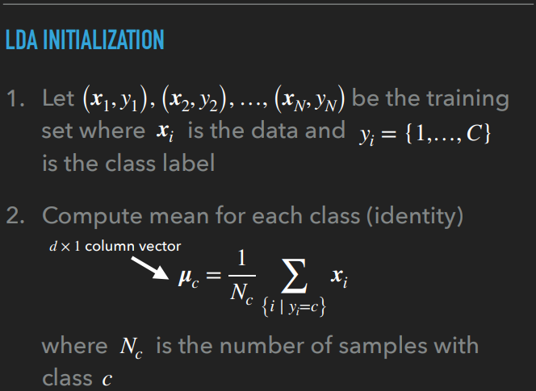
  + {i | yi = c} take only the values of i, such that yi = c.
  + 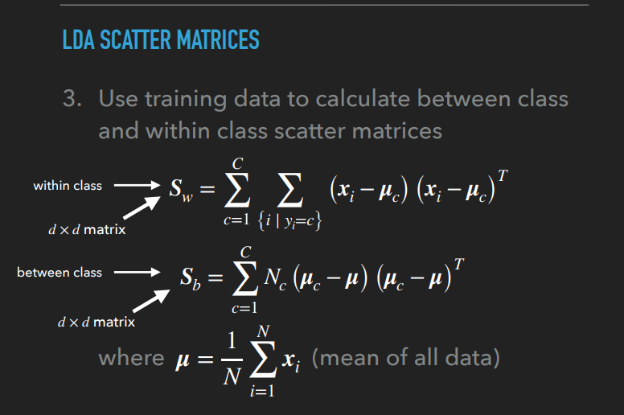
  + 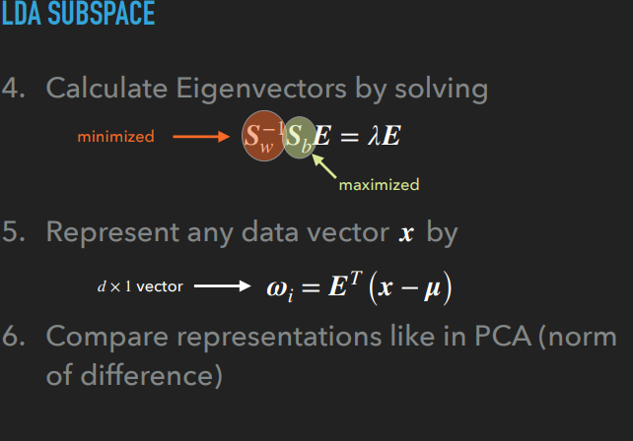
  + 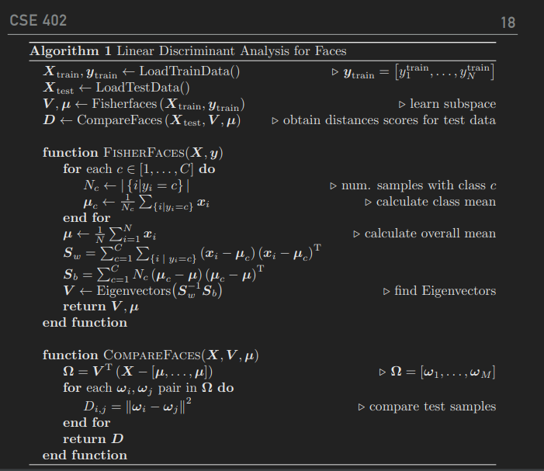
* Visualizing LDA Eigenvectors
  + Train on images from the ORL Face dataset
  + Obtain the Eigenvectors corresponding to the 5 largest Eigenvalues
    - Called Fisherfaces
  + Reshape from 1D vector to 2D image
  + 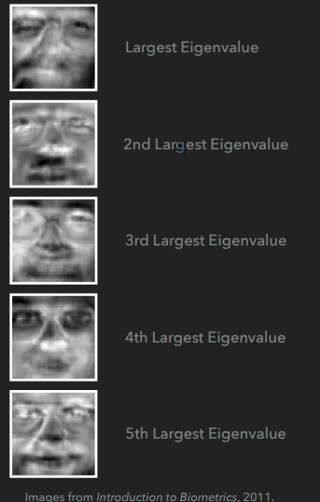
* PCA vs LDA
  + Choosing the Top “K” eigenvectors
    - 1. “K” is given
    - 2. 95% variance rule
      * Eigvec are ordered by eigvals.
      * Add up eigvals such that they are 95% of the total sum of eigenvalues.
      * Add until you reach a certain K. When the approximate sum of eigvals is 95%.(0.95)
      * Note: small eigenvalues do not provide significant data.
* ****Watch recording for equations analysis

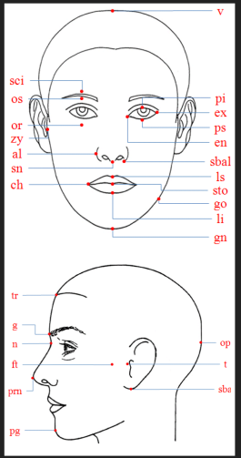

* Elastic Bunch Graph Matching (EBGM)
  + Model-based method
  + Robust to occlusions or pose
  + Uses Gabor filters at specific face landmarks
  + Organizes filter responses in a graph
* Face Landmarks
  + Point of interest on the face
    - ▸ corners of eyes
    - ▸ tip of the nose
    - ▸ corners of the mouth
    - ▸ etc.
  + ▸ Also known as fiducial points
* Gabor Filters
  + Apply a set of filters to a small area centered around each landmark
  + ▸ Total of 40 responses for each landmark
    - ▸ 8 different scales
    - ▸ 5 different directions
  + ▸ A set of filter responses is called a jet
  + 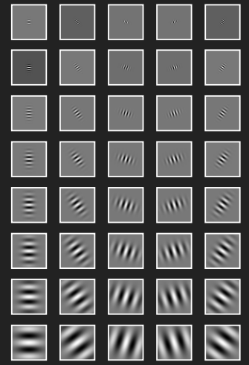
* Graphs
  + Structure consisting of nodes and edges
  + ▸ Edges relate nodes to one another
  + ▸ Edges may have an associated weight that defines a relationship between 2 nodes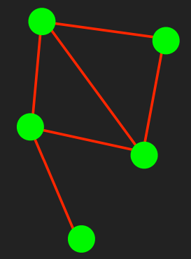
* Training - 1st Stage
  + Landmark points are identified manually for the first few images
  + ▸ Landmarks for subsequent images are discovered automatically by comparing the Gabor jets
  + ▸ Manual correction of mislabeled landmarks may be required
  + ▸ Edge weights denote the distance between face landmarks
  + 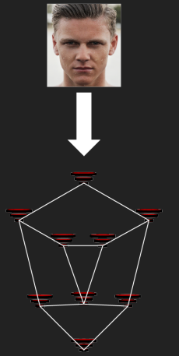
* Training - 2nd Stage
  + ▸ Image graphs are combined into a stack-like structure called a Face Bunch Graph (FBG)
  + ▸ The combined jets for a particular landmark is called a bunch
  + ▸ Several FBGs may be created for different poses
  + 